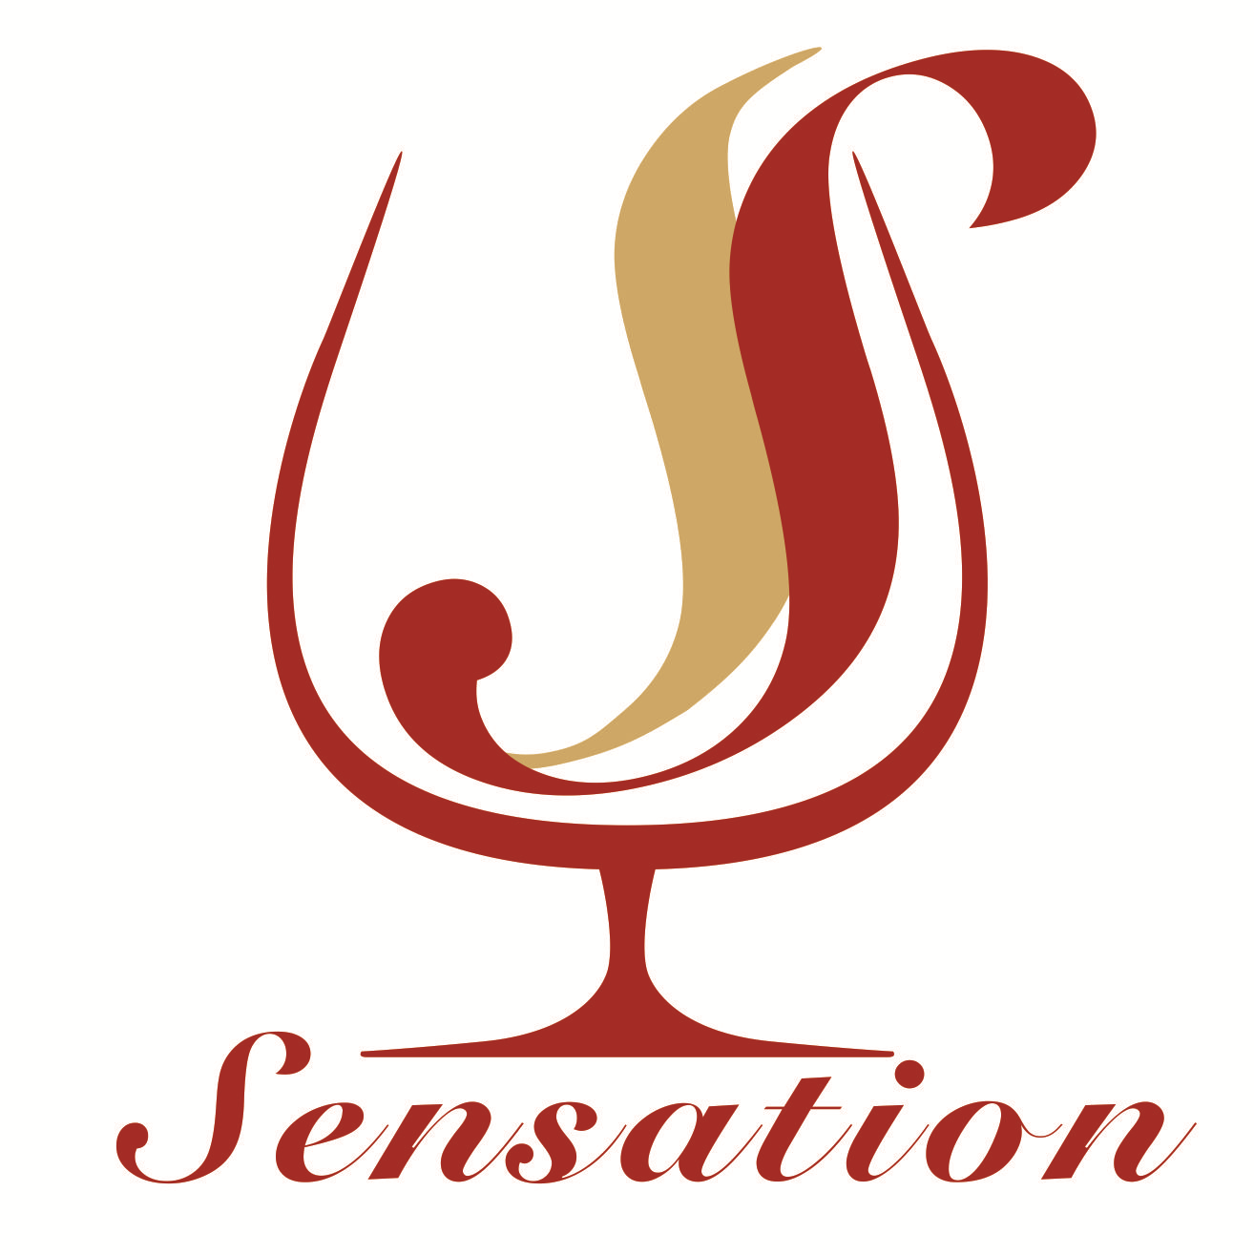 | 君航酒業公司  Sensation Wine Company

Order Form

Please call 90143131 or email isabell@sensationwine.com to contact Isabell for details.

The Wines | Price/Bottle | Quantity | Total
2008 Chateau Argadens | HK$140.00
2009 Chateau Perron | HK$210.00
2010 Chateau Trebiac | HK$140.00
2012 Domaine De Pellehaut  Lete Gascon | HK$130.00
2011 Domaine De Pellehaut  Ampelomeryx | HK$140.00
Total |  |  | HK$
* Free delivery for purchased above HK$800/order

Delivery Information
Receiver Name: __________________________________________
Address: _________________________________________________________________________________
Phone: __________________________________________
E-mail: __________________________________________

